T

TIBCO BusinessEvents BUI: Integration with Management Server

Product Suite | TIBCO BusinessEvents
Product | Business User Interface
Product Version | 1.0
Initial Author | Aditya Athalye

Copyright Notice
COPYRIGHT© 2008 TIBCO Software Inc. This document is unpublished and the foregoing notice is affixed to protect TIBCO Software Inc. in the event of inadvertent publication. All rights reserved. No part of this document may be reproduced in any form, including photocopying or transmission electronically to any computer, without prior written consent of TIBCO Software Inc. The information contained in this document is confidential and proprietary to TIBCO Software Inc. and may not be used or disclosed except as expressly authorized in writing by TIBCO Software Inc. Copyright protection includes material generated from our software programs displayed on the screen, such as icons, screen displays, and the like.
Trademarks
Technologies described herein are either covered by existing patents or patent applications are in progress. All brand and product names are trademarks or registered trademarks of their respective holders and are hereby acknowledged.
Confidentiality
The information in this document is subject to change without notice. This document contains information that is confidential and proprietary to TIBCO Software Inc. and may not be copied, published, or disclosed to others, or used for any purposes other than review, without written authorization of an officer of TIBCO Software Inc. Submission of this document does not represent a commitment to implement any portion of this specification in the products of the submitters.
Content Warranty
The information in this document is subject to change without notice. THIS DOCUMENT IS PROVIDED "AS IS" AND TIBCO MAKES NO WARRANTY, EXPRESS, IMPLIED, OR STATUTORY, INCLUDING BUT NOT LIMITED TO ALL WARRANTIES OF MERCHANTABILITY OR FITNESS FOR A PARTICULAR PURPOSE. TIBCO Software Inc. shall not be liable for errors contained herein or for incidental or consequential damages in connection with the furnishing, performance or use of this material.
For more information, please contact:
TIBCO Software Inc.
3307 Hillview Avenue
Palo Alto, CA 94304
USA
Table of Contents
Change Log 4
Organization: 5
Flow: 5
Scope: 6
Audience: 6
References: 6
Acronyms and Vocabulary 7
Interactions With MS: 8
1.) Login to the Management Server. – Connect To Engine (Menu) 8
1.1.1 Message Exchange Pattern: Request-Response (Synchronous). 8
1.1.2 Request: 8
1.1.3 Response: 9
1.1.4 Schema: 9
1.1.5 Service: 10
2.) Fetch Project From Storage. – Connection to Engine(Menu) 11
1.1.6 Message Exchange Pattern: Request-Response (Synchronous) 11
1.1.7 Request: 11
1.1.8 Response: 12
1.1.9 Schema: 15
1.1.10 Service: 19
3.) Push Project Updates to RCP clients: 20
1.1.11 Message Exchange Pattern: Solicit-Response. 20
1.1.12 Response: 20
4) Deploy Service 21
1.1.13 Message Exchange Pattern: Solicit-Response (Asynchronous). 21
1.1.14 Description: 21
1.1.15 Service: 24
6) Domain Model Service 24
1.1.16 Message Exchange Pattern: One-way (Request). 24
1.1.17 Request: 24
1.1.18 Schema: 25
1.1.19 Response: 26
1.1.20 Service: 26
7) Decision Project Structure 26
8) TIBCO Designer Decision Table extension 27
2 Implementation Design 28
2.1.1 Fetch Decision Project From MS: 28
2.1.2 Push Project update Notifications to RCP: 29

Change Log
.
SR. NO | Version | Name | Description
15 | 1.3.0 | Gabe Grigorescu | Updated Decision Project structure. Added section on TIBCO Designer extension. Added “BPM” use-case.
14 | 1.2.6 | Aditya Athalye | Amalgamated discreet schemas.
13 | 1.2.5 | Gabe Grigorescu | Cleaned up some comments, removed comments wherever I answered questions, fixed small document issues and formatting problems.
12 | 1.2.4 | Aditya Athalye | Added section on optimization of on-wire message using FastInfoSet.
11 | 1.2.3 | Aditya Athalye | Made few changes to the doc to incorporate Gabe’s review comments, as well as answer some of the questions in it.
10 | 1.2.2 | Gabe Grigorescu | More feedback and changes everywhere, doc clean-up changes (added decision project structure, etc)…
9 | 1.2.1 | Aditya Athalye | Added implementation design for Fetching project, and pushing project updates.
8 | 1.2.0 | Aditya Athalye | Added interaction for worklist creation, and also for fetching worklists when administrator logs in to BUI.
7 | 1.1.5 | Gabe Grigorescu | Added worklist requirements, decision project changes, quite a few other things as feedback.
6 | 1.1.4 | Aditya Athalye | Updated the doc with changed XML samples, interfaces for services to match REST.
5 | 1.1.3 | Aditya Athalye | Changed the format of the document to match TIBCO document standards.
4 | 1.1.2 | Aditya Athalye | Incorporated the Organization, and Flow sections to depict the Decision project concept.
3 | 1.1.1 | Aditya Athalye | Added example to show use of MTOM.
2 | 1.1 | Gabe Grigorescu | Updated spec.
1 | 1.0 | Aditya Athalye | Initial Draft.

Organization:

For BUI 1.0 we will introduce a concept of a Decision Project. The decision project will encompass the following:
- Ontology (read-only) which will be dumped in storage and which has been created through the TIBCO Designer tool.
- 0 or more decision tables (optionally decision trees)/rule functions (generated from Decision tables) using this ontology.
- Access Control Configuration file defined for this Decision Project.
- Domain Model Entries for this Decision Project.

Flow:

- User logs into the RCP by connecting to the Management Server, and receives the latest copy of the Decision Project available in the storage. This is of course subject to successful authentication.
- The RCP application explorer will be populated with the ontology coming from the designer project as well as with the Decision Tables/Trees/Rule Functions which were created as part of this Decision Project. (When no DT is present, this section will be empty).
- Domain model values for resources defined for this Decision Project will be displayed to the user on dragging a resource to a Decision Table from the explorer tree.
- A local in memory view of the Access Control Policy associated with this Decision Project will also be available. User will create/modify Decision Tables/Trees, and would want to persist it locally for working without connecting to server.
- When user clicks save, The entire Decision Project will be saved (including all DTs) (.decisionProject file/folder) inside a workspace selected by RCP user at startup.
- The explorer tree will be saved in a .ontology file inside the same location, whereas individual DTs which are part of this Decision Project will be saved with filenames corresponding to their names at the same location. Access Control memory model (if sent to client) will be persisted in binary/encrypted format with .access extension at the same location and the domain models for this Decision project inside .domainModels file. The .decisionProject file will have information about all the above mentioned files as well as the order of the Decision Tables/Trees when it was persisted.
- To open a decision project, user will select “Open” from the menu, and all the associated data will be shown. (explorer, DTs etc.)
- When a new DT is created through file menu, while saving the project each DT not yet associated with any ruleset will be prompted with a dialog box to select a ruleset to associate the DT. This information will then be persisted as shown:

Scope:
The scope of this document is to outline the integration of the BUI with the Management Server.
The document describes the usage of REST (Representational State Transfer) architecture for this integration. The HTTP server to be used will support the JSR-311 specification for JAX-RS.

Audience:
The document is intended for Developers, Architects, QA, Product Marketing, and Manager.

References:
- TIBCO Business Events Business User Interface Life Cycle.

Acronyms and Vocabulary

The table below describes some of the Acronyms used in this documentation
- BUI – Business User Interface
- MS – Management Server. A collection of REST style services to be deployed on an HTTP server to serve BUI with data, and set of operations on the data.
- Decision Project (DP) : A collection of the ontology created through TIBCO Designer, the Access Control policy file, Domain Models associated with the ontology, and any Decision Tables/Trees/Rule Functions created.
- BE – TIBCO BusinessEvents.
- XML – Extensible Markup Language
- Designer Project – A TIBCO Project build using TIBCO Designer. A Project is a VFileSystem which could typically be a Directory Node in the FileSystem.
- EAR – Enterprise Archive Resource. This is modeled from the J2EE world and contains a subset of VFiles, user defined files, properties, code, jars, etc. An Engine may choose to run against this EAR file.
- A Rule is single Conditions/Actions pair (e.g.,. a column in the Decision Table).

- DT – Decision Table. A Spread-Sheet like interface for business user to capture threshold values, business rules (in a tabular format). It comprises of one or more rules.
- A Rule Condition is a boolean expression of logical operators and functions (which may be a rule function or another Decision Table that returns a value) acting upon one or more Terms.
- A Rule Action is one of:
  - An update to a Term represented as an Expression
  - A creation or deletion of a Term
  - An invocation of another Decision Table that may or may not return a value
  - A simple return value (to be consumed by caller)

Interactions With MS:
The RCP will integrate with the Management Server for a variety of operations. The interactions and the services along with their interfaces are defined in this document.

1.) Login to the Management Server. – Connect To Engine (Menu)

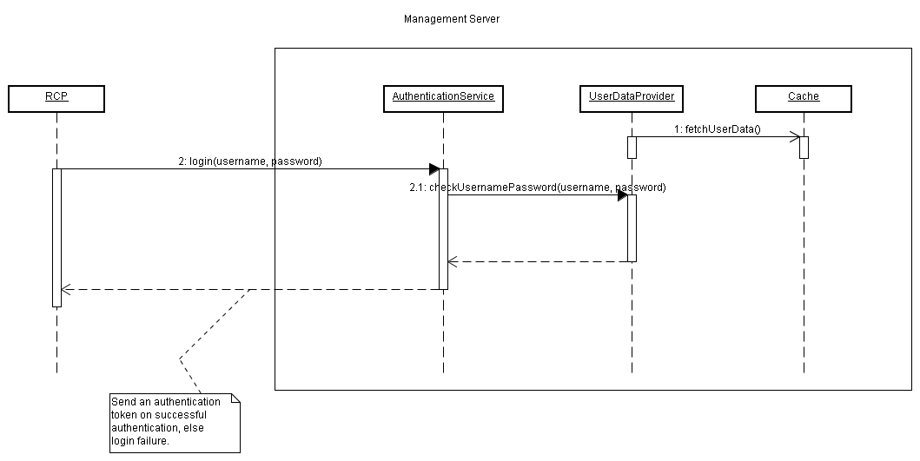

Message Exchange Pattern: Request-Response (Synchronous).

Request:
Send username/password in the Authorization Header (HTTP).

GET /services/projectservice/decisionproject HTTP/1.1
Accept: application/xml
Authorization:jhdaw7r87wyfiwu8379=

Response:

<AuthResponse xmlns:xsi="http://www.w3.org/2001/XMLSchema-instance" xsi:noNamespaceSchemaLocation="e:\svn\be-svn\decision\config\authen.xsd">
<authn>
<username>test</username>
<sessionToken>898798jhjhgggdayq81</sessionToken>
<authInstant>11:20:25</authInstant>
<authenticatedBy>http://localhost:8000/authenticate</authenticatedBy>
<expiry>5</expiry>
</authn>
<authz>
<roles>
<role name="BU"/>
</roles>
</authz>
</AuthResponse>

Schema:

<xs:schema xmlns:xs="http://www.w3.org/2001/XMLSchema">
<xs:element name="username">
<xs:simpleType>
<xs:restriction base="xs:string"/>
</xs:simpleType>
</xs:element>
<xs:element name="sessionToken">
<xs:simpleType>
<xs:restriction base="xs:string"/>
</xs:simpleType>
</xs:element>
<xs:element name="roles">
<xs:complexType>
<xs:sequence>
<xs:element ref="role" maxOccurs="unbounded"/>
</xs:sequence>
</xs:complexType>
</xs:element>
<xs:element name="role">
<xs:complexType>
<xs:attribute name="name" use="required">
<xs:simpleType>
<xs:restriction base="xs:string"/>
</xs:simpleType>
</xs:attribute>
</xs:complexType>
<xs:unique name="uniqueRoleName">
<xs:selector xpath="role"/>
<xs:field xpath="@name"/>
</xs:unique>
</xs:element>
<xs:element name="expiry">
<xs:simpleType>
<xs:restriction base="xs:byte">
<xs:enumeration value="5"/>
</xs:restriction>
</xs:simpleType>
</xs:element>
<xs:element name="authz">
<xs:complexType>
<xs:sequence>
<xs:element ref="roles"/>
</xs:sequence>
</xs:complexType>
</xs:element>
<xs:element name="authenticatedBy">
<xs:simpleType>
<xs:restriction base="xs:anyURI"/>
</xs:simpleType>
</xs:element>
<xs:element name="authInstant">
<xs:simpleType>
<xs:restriction base="xs:time"/>
</xs:simpleType>
</xs:element>
<xs:element name="auth">
<xs:complexType>
<xs:sequence>
<xs:element ref="username"/>
<xs:element ref="sessionToken"/>
<xs:element ref="authInstant"/>
<xs:element ref="authenticatedBy"/>
<xs:element ref="expiry"/>
</xs:sequence>
</xs:complexType>
</xs:element>
<xs:element name="AuthResponse">
<xs:complexType>
<xs:sequence>
<xs:element ref="auth"/>
<xs:element ref="authz"/>
</xs:sequence>
</xs:complexType>
</xs:element>
</xs:schema>

Service:

@UriTemplate("/services/authentication")
public class AuthenticationService extends HttpServlet {

@ProduceMime("application/xml")
@HttpMethod(“GET”)
public AuthenticationToken login(@HeaderParam
String encodedCreds) {}
}

The service interface shows that this authentication service can be accessed at the URI (URI_BASE/services/authentication where URI_BASE could be http://<host_name>:<port>). It accepts credentials for login inside the Authorization header which is mapped to the “encodedCreds” input parameter. This would need to be decoded using a Base64 decoder, and credentials used.
The response is an authentication token which is of XML content as depicted by @ProduceMime annotation.

2.) Fetch Project From Storage. – Connection to Engine(Menu)

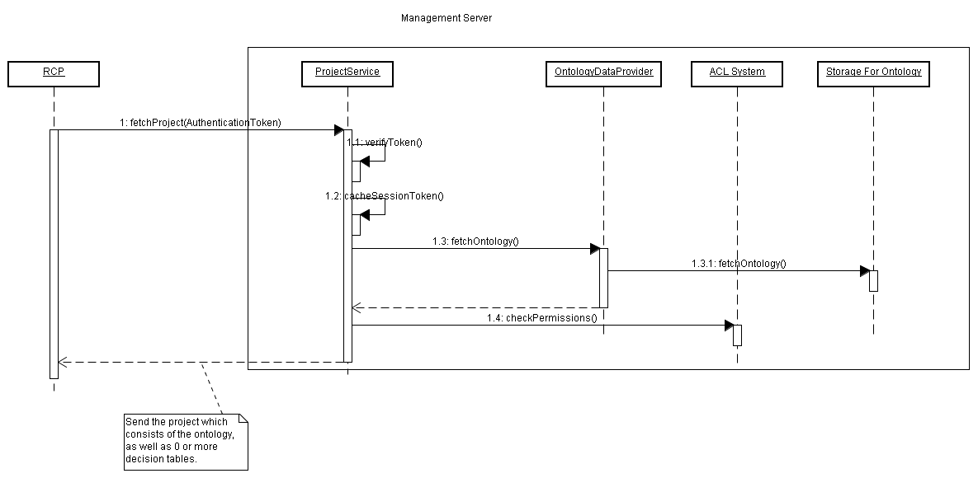

Message Exchange Pattern: Request-Response (Synchronous)

Request:

POST /services/projectservice/decisionproject HTTP/1.1
Accept: application/xml

<AuthResponse xmlns:xsi="http://www.w3.org/2001/XMLSchema-instance" xsi:noNamespaceSchemaLocation="e:\svn\be-svn\decision\config\authen.xsd">
<auth>
<username>test</username>
<sessionToken>898798jhjhgggdayq81</sessionToken>
<authInstant>11:20:25</authInstant>
<authenticatedBy>http://localhost:8000/authenticate</authenticatedBy>
<expiry>5</expiry>
</auth>
<authz>
<roles>
<role name="BU"/>
</roles>
</authz>
</AuthResponse>

Response:

HTTP/1.1 200 OK
Date: Tue, 12 Mar 2008 16:41:58 GMT
Server: Jersey/0.4ea
Content-Type: application/xml; charset=UTF-8
<?xml version="1.0" encoding="UTF-8"?>
<dp:DecisionProject xmlns:xsi="http://www.w3.org/2001/XMLSchema-instance" xmlns:dp="http:///com/tibco/cep/projectexplorer/model/decisionTable.ecore" xmlns:Table="http:///com/tibco/cep/decision/table/model/DecisionTable.ecore">
<dp:Ontology>
<resource xsi:type="dp:Ruleset" name="FraudDetection">
<rule name="ApplyDebit"/>
<rule name="FraudDetection"/>
<rule name="PublishSuspectAccounts"/>
</resource>
<resource xsi:type="dp:Folder" name="Rulesets">
<resource xsi:type="dp:Ruleset" name="FraudDetection">
<rule name="ApplyDebit"/>
<rule name="FraudDetection"/>
<rule name="PublishSuspectAccounts"/>
<resource xsi:type="dp:DecisionTable" name="CreditCardDT">
<Table:DecisionTable>
<columns/>
<argument type="BOTH">
<property domainOverriden="true" path="/Concepts/ChildFolder/DeepChild1/DeepChild2/DeepConcept" alias="deepconcept" type="NULL" graphicalPath="graphicalAliasPath" resourceType="CONCEPT"/>
</argument>
</Table:DecisionTable>
<Table:ExceptionTable>
<columns/>
</Table:ExceptionTable>
</resource>
</resource>

</resource>
<resource xsi:type="dp:Folder" name="Concepts">
<resource xsi:type="dp:Folder" name="ChildFolder">
<resource xsi:type="dp:Concept" name="NewConcept" superConceptPath=""/>
<resource xsi:type="dp:Concept" name="Account" superConceptPath="">
<property name="Id" historySize="1"/>
<property name="Balance" dataType="3" historySize="1"/>
<property name="AccountType" historySize="1"/>
<property name="Debits" dataType="3" historySize="5" historyPolicy="1"/>
<property name="Status" historySize="1"/>
<property name="AvgMonthlyBalance" dataType="3" historySize="1"/>
<property name="Openingdate" dataType="5" historySize="1"/>
</resource>
<resource xsi:type="dp:Folder" name="DeepChild1">
<resource xsi:type="dp:Folder" name="DeepChild2">
<resource xsi:type="dp:Concept" name="DeepConcept" superConceptPath=""/>
</resource>
</resource>
</resource>
<resource xsi:type="dp:Folder" name="Folder">
<resource xsi:type="dp:Concept" name="NewConcept" superConceptPath=""/>
</resource>
</resource>
<resource xsi:type="dp:Folder" name="FraudDefs">
<resource xsi:type="dp:Concept" name="Criteria1" superConceptPath="" scoreCard="true">
<property name="interval" dataType="2" historySize="1"/>
<property name="num_txns" dataType="1" historySize="1"/>
<property name="debits_percent" dataType="3"/>
</resource>
</resource>
<resource xsi:type="dp:Folder" name="Events">
<resource xsi:type="dp:Event" name="SuspectAccount">
<userProperty name="TransactionType" dataType="-1"/>
<userProperty name="Id" dataType="-1"/>
<userProperty name="Status" dataType="-1"/>
</resource>
<resource xsi:type="dp:Event" name="Debit">
<userProperty name="TransactionType" dataType="-1"/>
<userProperty name="AccountId" dataType="-1"/>
<userProperty name="Amount" dataType="-1"/>
</resource>
</resource>
</dp:Ontology>
<dp:DomainModels>
<DomainModel resource="/Concept/Account/Prop1" type="" resourceType="PROPERTY" xmlns:xsi="http://www.w3.org/2001/XMLSchema-instance" xmlns:DomainModel="http:///com/tibco/cep/decision/table/model/DomainModel.ecore">
<domainEntry>
<entryValue xsi:type="DomainModel:SingleValue" value="true"/>
</domainEntry>
<domainEntry>
<entryValue xsi:type="DomainModel:SingleValue" value="false"/>
</domainEntry>
</DomainModel>
<DomainModel resource="/Concept/Account/Prop2" type="" resourceType="PROPERTY" xmlns:xsi="http://www.w3.org/2001/XMLSchema-instance" xmlns:DomainModel="http:///com/tibco/cep/decision/table/model/DomainModel.ecore">
<domainEntry>
<entryValue xsi:type="DomainModel:SingleValue" value="true"/>
</domainEntry>
<domainEntry>
<entryValue xsi:type="DomainModel:SingleValue" value="false"/>
</domainEntry>
</DomainModel>
</dp:DomainModels>
<dp:Access>
987rhwfjhfiuy9r824940918e0jfoihfwr0768174571687udyiujhJHAOIHD87T726483274924039240242YRHFDIUEWGFIWUFWUF878747918098R098609739867==
</dp:Access>
</dp:DecisionProject>

This represents a sample representation of the project persisted in the cache. As can be seen, there will be 0 or more decision tables inside this. When the project is loaded by the RCP for the first time, there will be no decision tables inside this.
The service will send ontology after checking permissions for the logged in user (role-based).
Note that the XML representation above simply indicates that this is the data that will be sent. To optimize the on-wire transmission, as well as for quick parsing, we may encode this data using the FastInfoSet specification from W3C. A sample on the wire message could look like this:

à____xÏ_xsi(http://www.w3.org/2001/XMLSchema-instanceÏ_dp>http:///com/tibco/cep/projectexplorer/model/decisionTable.ecoreÏ_Table=http:///com/tibco/cep/decision/table/model/DecisionTable.ecoreð?‚‚_DecisionProject{
schemaLocation_hhttp:///com/tibco/cep/projectexplorer/model/decisionTable.ecore e:\svn\be-svn\decision\config\decisionproject.xsdð‘
?‚‚ Ontology’_
| resource{_typeH_dp:Rulesetx_nameH_FraudDetectionð’_
|_rule_H_ApplyDebitÿ¢C_ÿ¢C_H
PublishSuspectAccountsÿ¡ð¡B_H_dp:Folder_GRulesetsð¢B_€_ð’_
C_‚ÿ£C_ÿ£C_ƒÿ¢ð¢B_H dp:DecisionTable_H_CreditCardDTð£?ƒƒDecisionTable’_
<_columnsð¤| argumentx„CBOTHð’_
| propertyx_domainOverridenCtruex_path_./Concepts/ChildFolder/DeepChild1/DeepChild2/DeepConceptx_aliasH_deepconcept_CNULLx
graphicalPathH graphicalAliasPathx
resourceTypeFCONCEPTÿ¤ð£ð£?ƒƒ
ExceptionTable¤_ð£ð¢ð¡ð¡B_„_GConceptsð¢B_„_H_ChildFolderð£B_H_dp:Concept_H_NewConceptx_superConceptPathÿÿ£B__FAccount ÿð¤G_AIdx
historySize@1ÿ¤G_FBalancex dataType@3
”ÿ¤G_H_AccountType
”ÿ¤G_EDebits
–
@5xhistoryPolicy”ÿ¤G_EStatus
”ÿ¤G_H_AvgMonthlyBalance
–
”ÿ¤G_H_Openingdate
™
”ÿ£ð£B_„_H_DeepChild1ð¤B_„_H_DeepChild2ð¥B__H_DeepConcept ÿÿ¤ð£ð¢ð¢B_„_EFolderð£B__‘ ÿÿ¢ð¡ð¡B_„_H_FraudDefsð¢B__H_Criteria1 ÿx_scoreCard‰ð£G_Ginterval
@2
”ÿ£G_Gnum_txns
”
”ÿ£G_H_debits_percent
–ÿ¢ð¡ð¡B_„_EEventsð¢B_Gdp:Event_H_SuspectAccountð£|
userProperty_H_TransactionType
A-1ÿ£I_“
«ÿ£I_š
«ÿ¢ð¢B_¨_DDebitð£I_ª
«ÿ£I_H_AccountId
«ÿ£I_EAmount
«ÿ¢ð¡ð ð ?‚‚
DomainModels¡xÏÏ
DomainModel;http:///com/tibco/cep/decision/table/model/DomainModel.ecoreð<
DomainModelxƒH
/Concept/Account/Prop1_ÿ_GPROPERTYð¢<
domainEntry£| entryValue_H_DomainModel:SingleValuex_value‰ÿ¢ð¢£M_±_Dfalseÿ¢ð¡ð¡xÏÏ„„ð
_H
/Concept/Account/Prop2_ÿ_°ð¢£M_±_‰ÿ¢ð¢£M_±_²ÿ¢ð¡ð ð ?‚‚_Access‚987rhwfjhfiuy9r824940918e0jfoihfwr0768174571687udyiujhJHAOIHD87T726483274924039240242YRHFDIUEWGFIWUFWUF878747918098R098609739867== ð
ÿ

The FastInfoset data would be converted then to its XML infoset form (In this case XMI). Refer http://asn1.elibel.tm.fr/xml/finf.htm for details on FastInfoset.

Schema:
<?xml version="1.0" encoding="UTF-8"?>
<xs:schema xmlns:dp="http:///com/tibco/cep/projectexplorer/model/decisionTable.ecore" xmlns:xs="http://www.w3.org/2001/XMLSchema" xmlns="http:///com/tibco/cep/projectexplorer/model/decisionProject.ecore" targetNamespace="http:///com/tibco/cep/projectexplorer/model/decisionProject.ecore">
<xs:complexType name="Ruleset">
<xs:complexContent>
<xs:extension base="T_resource"/>
</xs:complexContent>
</xs:complexType>
<xs:complexType name="Folder">
<xs:complexContent>
<xs:extension base="T_resource"/>
</xs:complexContent>
</xs:complexType>
<xs:complexType name="Event">
<xs:complexContent>
<xs:extension base="T_resource"/>
</xs:complexContent>
</xs:complexType>
<xs:complexType name="DecisionTable">
<xs:complexContent>
<xs:extension base="T_resource"/>
</xs:complexContent>
</xs:complexType>
<xs:complexType name="Concept">
<xs:complexContent>
<xs:extension base="T_resource"/>
</xs:complexContent>
</xs:complexType>
<xs:element name="Ontology">
<xs:complexType>
<xs:sequence>
<xs:element ref="resource" maxOccurs="unbounded"/>
</xs:sequence>
</xs:complexType>
</xs:element>
<xs:element name="DomainModels">
<xs:complexType>
<xs:sequence>
<xs:element ref="DomainModel" maxOccurs="unbounded"/>
</xs:sequence>
</xs:complexType>
</xs:element>
<xs:element name="DecisionProject">
<xs:complexType>
<xs:sequence>
<xs:element ref="Ontology"/>
<xs:element ref="DomainModels"/>
<xs:element ref="Access"/>
</xs:sequence>
</xs:complexType>
</xs:element>
<xs:element name="Access" type="xs:string"/>
<xs:complexType name="T_resource">
<xs:choice minOccurs="0">
<xs:element ref="property" maxOccurs="unbounded"/>
<xs:element ref="resource" maxOccurs="unbounded"/>
<xs:element ref="rule" maxOccurs="unbounded"/>
<xs:element ref="userProperty" maxOccurs="unbounded"/>
<xs:sequence>
<xs:element ref="DecisionTable"/>
<xs:element ref="ExceptionTable"/>
</xs:sequence>
</xs:choice>
<xs:attribute name="superConceptPath">
<xs:simpleType>
<xs:restriction base="xs:string"/>
</xs:simpleType>
</xs:attribute>
<xs:attribute name="scoreCard" type="xs:boolean"/>
<xs:attribute name="name" use="required">
<xs:simpleType>
<xs:restriction base="xs:string"/>
</xs:simpleType>
</xs:attribute>
</xs:complexType>
<xs:complexType name="T_entryValue">
<xs:attribute name="value" type="xs:boolean" use="required"/>
</xs:complexType>
<xs:element name="userProperty">
<xs:complexType>
<xs:attribute name="name" use="required">
<xs:simpleType>
<xs:restriction base="xs:string"/>
</xs:simpleType>
</xs:attribute>
<xs:attribute name="dataType" use="required">
<xs:simpleType>
<xs:restriction base="xs:byte"/>
</xs:simpleType>
</xs:attribute>
</xs:complexType>
</xs:element>
<xs:element name="rule">
<xs:complexType>
<xs:attribute name="name" use="required">
<xs:simpleType>
<xs:restriction base="xs:string"/>
</xs:simpleType>
</xs:attribute>
</xs:complexType>
</xs:element>
<xs:element name="resource" type="T_resource"/>
<xs:element name="property">
<xs:complexType>
<xs:attribute name="type">
<xs:simpleType>
<xs:restriction base="xs:string"/>
</xs:simpleType>
</xs:attribute>
<xs:attribute name="resourceType">
<xs:simpleType>
<xs:restriction base="xs:string">
<xs:enumeration value="CONCEPT"/>
<xs:enumeration value="PROPERTY"/>
<xs:enumeration value="EVENT"/>
</xs:restriction>
</xs:simpleType>
</xs:attribute>
<xs:attribute name="path" type="xs:string"/>
<xs:attribute name="name">
<xs:simpleType>
<xs:restriction base="xs:string"/>
</xs:simpleType>
</xs:attribute>
<xs:attribute name="historySize">
<xs:simpleType>
<xs:restriction base="xs:byte"/>
</xs:simpleType>
</xs:attribute>
<xs:attribute name="historyPolicy">
<xs:simpleType>
<xs:restriction base="xs:byte"/>
</xs:simpleType>
</xs:attribute>
<xs:attribute name="graphicalPath">
<xs:simpleType>
<xs:restriction base="xs:string">
<xs:enumeration value="graphicalAliasPath"/>
</xs:restriction>
</xs:simpleType>
</xs:attribute>
<xs:attribute name="domainOverriden" type="xs:boolean"/>
<xs:attribute name="dataType">
<xs:simpleType>
<xs:restriction base="xs:byte"/>
</xs:simpleType>
</xs:attribute>
<xs:attribute name="alias">
<xs:simpleType>
<xs:restriction base="xs:string"/>
</xs:simpleType>
</xs:attribute>
</xs:complexType>
</xs:element>
<xs:element name="entryValue" type="T_entryValue"/>
<xs:element name="domainEntry">
<xs:complexType>
<xs:sequence>
<xs:element ref="entryValue"/>
</xs:sequence>
</xs:complexType>
</xs:element>
<xs:element name="columns">
<xs:complexType/>
</xs:element>
<xs:element name="argument">
<xs:complexType>
<xs:sequence>
<xs:element ref="property"/>
</xs:sequence>
<xs:attribute name="type" use="required">
<xs:simpleType>
<xs:restriction base="xs:string"/>
</xs:simpleType>
</xs:attribute>
</xs:complexType>
</xs:element>
<xs:element name="DomainModel">
<xs:complexType>
<xs:sequence>
<xs:element ref="domainEntry" maxOccurs="unbounded"/>
</xs:sequence>
<xs:attribute name="type" use="required">
<xs:simpleType>
<xs:restriction base="xs:string">
<xs:enumeration value=""/>
</xs:restriction>
</xs:simpleType>
</xs:attribute>
<xs:attribute name="resourceType" use="required">
<xs:simpleType>
<xs:restriction base="xs:string">
<xs:enumeration value="CONCEPT"/>
<xs:enumeration value="PROPERTY"/>
<xs:enumeration value="EVENT"/>
</xs:restriction>
</xs:simpleType>
</xs:attribute>
<xs:attribute name="resource" use="required">
<xs:simpleType>
<xs:restriction base="xs:string"/>
</xs:simpleType>
</xs:attribute>
</xs:complexType>
</xs:element>
<xs:complexType name="SingleValue">
<xs:complexContent>
<xs:extension base="T_entryValue"/>
</xs:complexContent>
</xs:complexType>
<xs:element name="ExceptionTable">
<xs:complexType>
<xs:sequence>
<xs:element ref="columns"/>
</xs:sequence>
</xs:complexType>
</xs:element>
<xs:element name="DecisionTable">
<xs:complexType>
<xs:sequence>
<xs:element ref="columns"/>
<xs:element ref="argument"/>
</xs:sequence>
</xs:complexType>
</xs:element>
</xs:schema>

Service:

@UriTemplate(“/services/project/decisionproject”)
Public class ProjectService extends HttpServlet {

@HttpMethod(“POST”)
@ProduceMime(“application/xml”)
@ConsumeMime(“application/xml”)
Public DecisionProject fetchProject(AuthenticationToken token) throws Exception {}

@HttpMethod(“PUT”)
@ConsumeMime(“application/xml”)
Public void updateProject(AuthenticationToken token, DecisionProject project) throws Exception {}

@HttpMethod
Public DecisionProject pushProject() throws Exception {}
}

Method (fetchProject) is called by BUI once user logs in to the Management Server. Since it accepts input as a valid authentication token which was received from the login service, the @ConsumeMime annotation is added to depict the incoming message nature. The response produced is XML which is shown above and hence the @ProduceMime annotation.
The (updateProject) method is called when RCP user wants to commit his/her decision table to the server. (Akin to a checkin inside a source control.) This invocation will invoke the BE state machine which shows state transitions of the decision project submitted by the user. This method accepts XML content. The response is not synchronous (as this is a workflow invocation), and hence only acknowledgement will be sent using HTTP status code (200 OK).

3.) Push Project Updates to RCP clients:

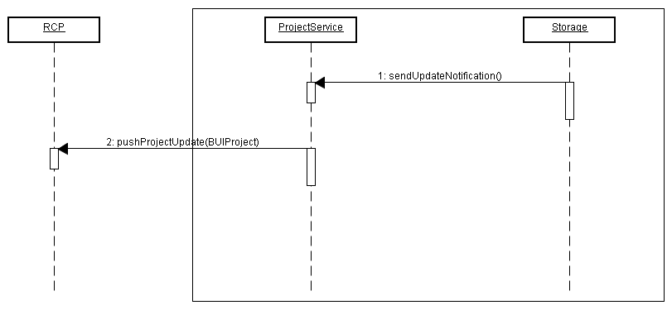

Message Exchange Pattern: Solicit-Response.

Response:

Same as the response in the fetchProject. How do we send this response? Do we simply send notifications/callbacks on client sides when something in the project changed? How do we take care of this given the pull model restriction imposed by REST?

4) Deploy Service

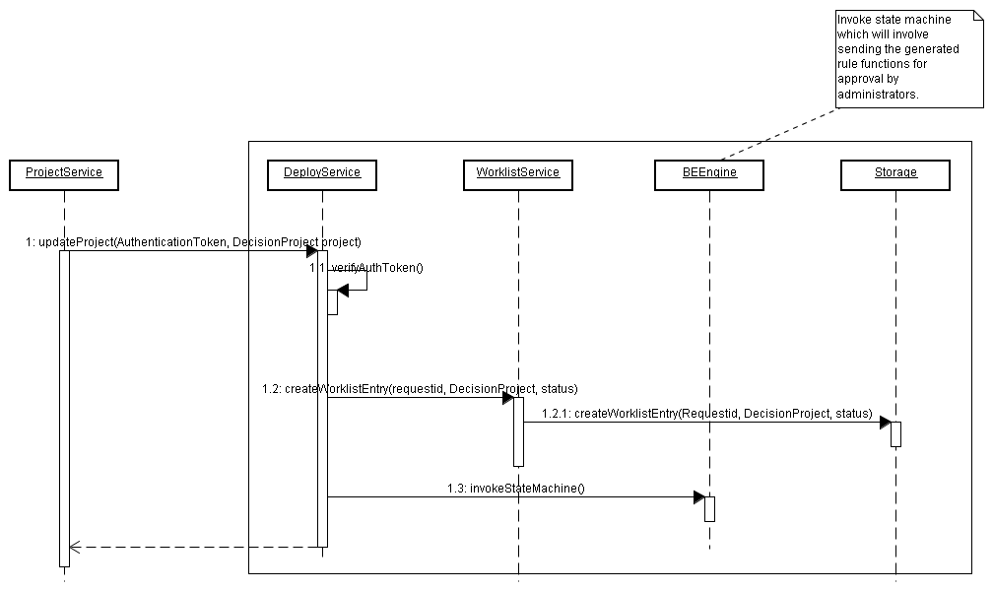

Message Exchange Pattern: Solicit-Response (Asynchronous).

Description:

The RCP user after verifying the Decision Table logic, sends a request to the Deployment Service. Inputs to the service are the authentication token which is required to be verified before each service is requested, and a list of rule functions which are to be deployed.

Flow:
1.) Business User calls update project on Project service. (Commit Menu).
Server accepts the commit request, and sends the Business user with a request id which is unique.
A worklist entry is created in the worklist storage which contains request id, the decision project submitted by Business User, and status set to “Approval Pending”.
IT administrator logs in, and clicks on Menu option (Show My Worklists).
Server sends a list of request ids, names of their corresponding Decision Projects (The name has to be unique inside the scope), and status.
A wizard opens up on the BUI which shows a list of request ids with “Approval Pending” status.

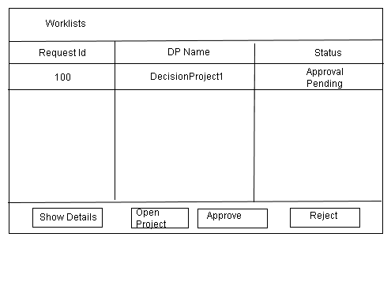
The Show Details will show details like the submitter (user), time of submission etc.
The administrator may review the rule function using TIBCO designer, or any other means suitable. The means to do this is out of scope of this release.
The wizard can be minimized (Non-Modal) so that IT admin can review the Decision Project submitted by Business User.
When the IT administrator approves the project, the status changes to “Approved”, and the Decision Project gets committed to the server. (There is always one copy in the main repository, whereas the worklist repository will contain data of all pending approval Decision Projects. When project is fetched upon login, it is always from the main storage area that the project will be served.)
If however, the Project is rejected, the status is changed to “Rejected”, the Decision Project is not submitted, and the IT administrator may optionally add Comments/reasons for rejection.
Business User should be able to view requests submitted by him/her after logging in. This should be available through menu option (“Show My Requests”). On clicking this option, same wizard should pop-up (shown above but with different title) with only those request ids that the Business user had created. The status should be displayed alongwith the id. Also the approve/reject buttons should NOT be present.

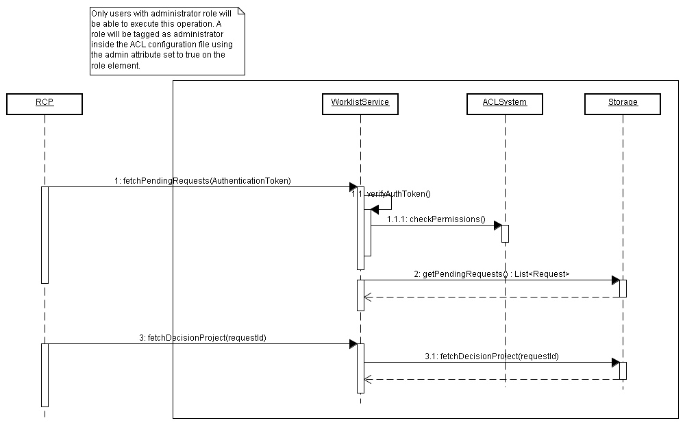

The diagram shows how IT administrator (role name=”IT” admin=”true”) will request for worklist having Pending Approval status. These worklists will not be separated on basis of a user (This is more of delegated administration which we cannot do in this release given the time constraint), so all users belonging to administrator role can view and approve worklists.
If request is approved, it will be sent to the deployer to create a deployable consisting of the existing ontology as well as the newly added rule functions. This will be done using existing TIBCO designer tool, and the TIBCO administrator deployment service.

Service:
@UriTemplate(“/services/deployment”)
Public class DeploymentService extends HttpServlet {

@HttpMethod(“GET”)
Public Response invokeWorkflow() {
}

The above service can be invoked by the Project service when Decision Project updated by RCP user has to be committed to server, and then sent for deployment.

6) Domain Model Service

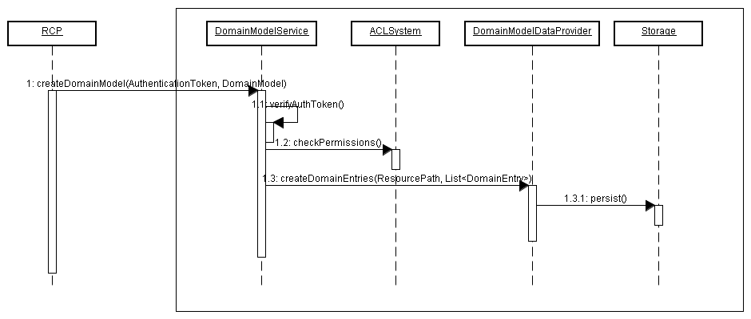

Message Exchange Pattern: One-way (Request).

Request:

A sample request to create domain model for a certain resource could look like this:

POST /services/domainmodel/ HTTP/1.1
Host: host1.apac.tibco.com
Accept: application/xml

<DomainModel resource="" type="" resourceType="PROPERTY" xmlns:xsi="http://www.w3.org/2001/XMLSchema-instance" xmlns:DomainModel="http:///com/tibco/cep/decision/table/model/DomainModel.ecore" xsi:noNamespaceSchemaLocation="e:\svn\be-svn\decision\config\domainmodel.xsd">
<domainEntry>
<entryValue xsi:type="DomainModel:SingleValue" value="true"/>
</domainEntry>
<domainEntry>
<entryValue xsi:type="DomainModel:SingleValue" value="false"/>
</domainEntry>
</DomainModel>

Schema:

<xs:schema xmlns:xs="http://www.w3.org/2001/XMLSchema" xmlns:ns1="http:///com/tibco/cep/decision/table/model/DomainModel.ecore">
<xs:complexType name="T_entryValue">
<xs:attribute name="value" type="xs:boolean" use="required"/>
</xs:complexType>
<xs:element name="entryValue" type="T_entryValue"/>
<xs:element name="domainEntry">
<xs:complexType>
<xs:sequence>
<xs:element ref="entryValue"/>
</xs:sequence>
</xs:complexType>
</xs:element>
<xs:element name="DomainModel">
<xs:complexType>
<xs:sequence>
<xs:element ref="domainEntry" maxOccurs="unbounded"/>
</xs:sequence>
<xs:attribute name="type" use="required">
<xs:simpleType>
<xs:restriction base="xs:string">
</xs:restriction>
</xs:simpleType>
</xs:attribute>
<xs:attribute name="resourceType" use="required">
<xs:simpleType>
<xs:restriction base="xs:string">
<!—More enumeration values could be added →
<xs:enumeration value="PROPERTY"/>
<xs:enumeration value="CONCEPT"/>
<xs:enumeration value="EVENT"/>
</xs:restriction>
</xs:simpleType>
</xs:attribute>
<xs:attribute name="resource" use="required">
<xs:simpleType>
<xs:restriction base="xs:string">
</xs:restriction>
</xs:simpleType>
</xs:attribute>
</xs:complexType>
</xs:element>
<xs:complexType name="SingleValue">
<xs:complexContent>
<xs:extension base="T_entryValue"/>
</xs:complexContent>
</xs:complexType>
</xs:schema>

Response:

HTTP/1.1 200 OK

Service:

@UriTemplate(“/services/domainmodel”)
Public class DomainModelService extends HttpServlet {

@HttpMethod(“POST”)
@ConsumeMime(“application/xml”)
Public void createDomainModel(DomainModel model) {}

@HttpMethod(“DELETE”)
@ConsumeMime(“application/xml”)
Public void removeDomainEntries(DomainModel model) {}

@HttpMethod(“PUT”)
@ConsumeMime(“application/xml”)
Public void modifyDomainValue(DomainModel model) {}

}

The DomainModel object in the above code should contain information about the resource for which the model has to be created/removed/modified and the list of domain entries for the same. Please refer the request XML for an idea on how this would look like.

Updates to domain model will be pushed to RCP clients as part of “Push Updates” from Project Service.

7) Decision Project Structure

Once the RCP user selects to save the project on the local disk to a location like “C:\myprojects\BankingExample” the project will be persisted as follows inside this directory:
.decisionproject
<ontology directory structure>
.access
.domainmodel

Part of the “<ontology directory structure>” we will see all the ontology objects stored in the same way that designer stores them. Among those files there will be .dtable (and .rulefunction) files according to the place where they are stored. For example, one could have:
C:\myprojects\BankingExample:

.decisionproject
.access
.domainmodel

Concepts/
Person.concept
Rules/
InitializeData.rulefunction
MyRuleSet.ruleset
MyRuleSet.SomeTableName.dtable -- a DT named “SomeTableName” that’ll show up under “/Rules/MyRuleSet”)
MyOtherRuleSet.ruleset
MyOtherRuleSet.SomeTableName.dtable
MyOtherRuleSet.AnotherTable.dtable
(MyOtherRuleSet.AnotherTable.rulefunction) -- optional

Events/
ApplicationReceived.event
Misc/
….

8) TIBCO Designer Decision Table extension

A new Designer resource type will be added to support the idea of a Decision Table template. In this scenario, the IT person will add such a resource to the desired ruleset and specify its inputs. The inputs can be any number of Entities (concepts or events, but not their properties). Then, when the business user gets the ontology from the server, they will “Fill in” this table with the business logic. In this case, the user should not be able to DnD any properties of concepts that are not in the scope of the decision table input arguments.

Implementation Design

Fetch Decision Project From MS:

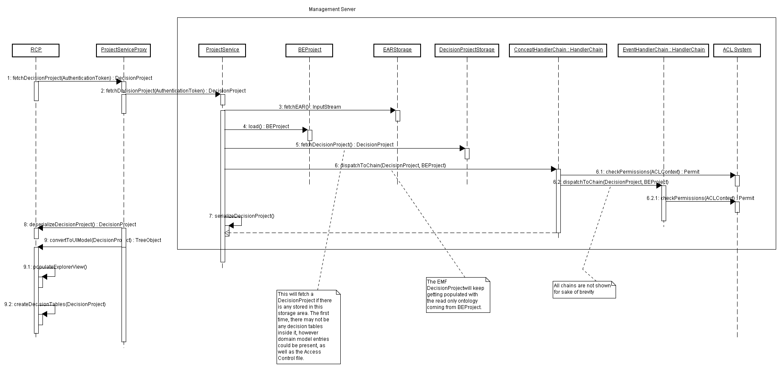

Push Project update Notifications to RCP:

